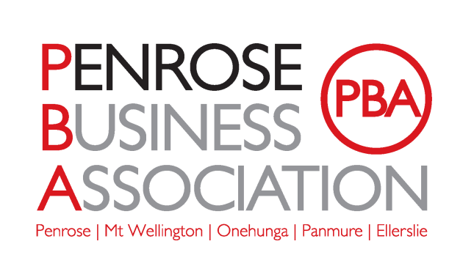

**Minutes of Annual General Meeting of the Penrose Business Association Inc.**

**16 October 2024**

**Venue: Auckland Harley Davidson, 521 Mount Wellington Highway, Mount Wellington**

Meeting was opened at 16:38p.m. by the Chair Peter Lamberton.

**Present:** 2023-2024 Executive Committee members – Peter Lamberton, Ralph Taylor, Tony Aislabie, Ray Pratt, Paul Wilson, Steve Kelland, Robynne Pringle (Manager), Joanne Tonepohl (Secretary), David Wylie, Experience on Tap, David Johns, Linak New Zealand, Rani Nalam The Mortgage Supply Co, Phillip Cashmore Machinetech Ltd. Pak n Send, Sarah-Jane O’Brien, Lucidity Cloud Services.

**Apologies**: Jonathan Spence, Xtracta Ltd; Shelley Trutsch, Waipuna Hotel; Vince Patena, PR Hotels.

**Resignations from Executive Committee:** Paul Wilson

**Previous Minutes:**  The previous year’s minutes were provided for attendees to read and comment on. They were accepted in a motion by Ray Pratt, and seconded by Peter Lamberton, all were in favour.

**Chairman’s Report:**

Membership is slightly up from last year we are competent at bringing people on, not necessarily good at retaining them.

We do events as frequently as we can, budget permitting, we did ten this year including the National Party event, we put on some rather good events thanks to Robynne and Joanne. We also focus on advocacy and try to influence Council/local Board. We have submitted our voice to a reasonable number of submissions etc. including the East/West link submission with Simeon Brown.

Financial Position income was up slightly on last year this was due mainly to sponsorship. Expenses are the same. Overall, we are pretty stable.

2025 goals are to continue with events and advocacy, put in a new constitution, please put in any input that you feel we need regarding this.

Potentially whether we become a BID – we have committed to investigate this and have had some funding from the Local Board to do this $10.000 this year and $15,000 for the following two years.

Peter also thanked the ongoing support of the volunteers who make up the executive Committee for all their passion and drive to make the orgainisation what it is today. He also thanked Robynne and Joanne for their invaluable contribution.

A word of thanks to the committee and staff and to Paul who is stepping down this year. He feels privileged to work with everyone.

Thans to the sponsors, the PBA is contingent on sponsors, and they make a very big difference, and we hope it makes their investment worthwhile.

There were no objections to the Chairman’s Report, and it was accepted.

Moved: Peter Lamberton, Seconded Tony Aislabie, All in favour.

**Annual Accounts:** The annual accounts have been circulated.

We more or less broke even through the year and had a very small deficit. We have never had more than $25,000 in the accounts and have never been below where we are at the moment.

There were no questions on the financial report.

The Accounts were approved and accepted as read.

Moved Peter Lamberton, Seconded Tony Aislabie , all in favour.

**Committee Nominations**: We have one resignation Paul Wilson

Everyone who has stood this year is remaining apart from Paul. Nominations were read out by Peter Lamberton. Nominations closed on 11th October 2024. All Accepted.

Nominations for Executive Committee Members are:

Peter Lamberton, Primeacc Ltd as Chairman; Jonathan Spence, Xtracta Ltd as Treasurer; Tony Aislabie, Concentric Engineered Solutions as Executive Member, Steve Kelland, Machinery Relocations Ltd as Executive Member; Ray Pratt, Auckland Harley Davidson as Executive Member; Sarah-Jane O’Brien, Lucidity Cloud Services as Executive Member; and Dave Johns, Linak New Zealand as Executive Member. .

On the basis that we have seven nominations and can have eleven, we don’t require a vote.

It was proposed that all the nominations are accepted.

Peter Lamberton and seconded Ray Pratt.

Ralph Taylor is an Associate Member and so cannot be nominated to join the Committee but can be invited onto it at our next Executive meeting. This is to be held on the second Tuesday of every month.

**General Business:**

Do we have an area that PBA covers? This might be of value to people that are in the area and don’t know it. Our area is fairly broad. The funding we receive from the Council will help with defining this.

What we do as committee members was discussed.

Peter Lamberton called the 2024 Annual General Meeting to a close at 17:11p.m.